**QEA Tech UltraMax Batch Enhancer**

**(Version 2.0)**

***User Manual Documentation***

**Contents**

**Purpose** 3

**Version** 3

**User Manual** 3

**User Interface** 4

**User Interaction** 5

1. Upload Image(s) 5

2. Enhance Image(s) 8

3. Reset Image(s) 10

4. View Image(s) Folder 11

# **Purpose**

The QEA Tech UltraMax Batch Enhancer is designed by QEA Tech to perform thermal enhancement on large sets of FLIR-generated Thermal Image files in a batch process. Rather than manually generating UltraMax images on an image-by-image basis, users are now able to convert hundreds of images to UltraMax, with just one click of a button. Developed by FLIR, UltraMax technology further enhances the resolution of Thermal Image files that are being generated, with their radiometric data readily available for post-processing analysis. As a result of leveraging FLIR’s UltraMax technology, we are able to measure temperature more accurately.

# **Version**

Released on July 10, 2020, Version 2 of the QEA Tech UltraMax Batch Enhancer software includes multiple feature enhancements, including the ability to upload files that are of .jpg file format, Thermal Image file type, and ready for UltraMax enhancement, with one click of a button. In doing so, users can seamlessly upload and work solely on the Thermal Image files that need to be enhanced using UltraMax, providing both time and cost efficiencies for the organization.

# **User Manual**

This document serves as a guide for end-users and provides the user interface and entire experience to effectively use the QEA Tech UltraMax Batch Enhancer application. For more information on how to use the application, please e-mail [support@qeatech.com](mailto:support@qeatech.com).

# **User Interface**

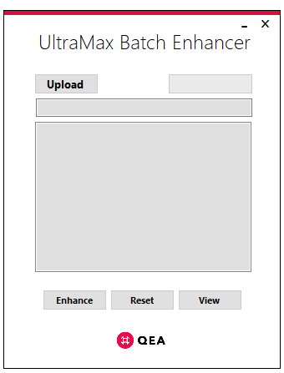

**Components**

|  |  |  |
| --- | --- | --- |
| **ID** | **NAME** | **PURPOSE** |
| 1 | Upload Image(s) | Upload Thermal Image(s) for batch enhancement |
| 2 | Enhance Image(s) | Enhance the uploaded Thermal Image(s) |
| 3 | Reset Image(s) | Reset the uploaded/enhanced Thermal Image(s) |
| 4 | View Image(s) Folder | View the folder containing the enhanced Thermal Image(s) |
| 5 | Progress Bar | Indicate progress of the Batch Enhancer application |
| 6 | Folder Path | Display the selected folder path containing Thermal Image(s) |
| 7 | Image(s) List | Display the selected list of Thermal Image(s) |
| 8 | Close/Minimize Form | Close or minimize the Batch Enhancer application |

# **User Interaction**

# Upload Image(s)

1. Click on “Upload”

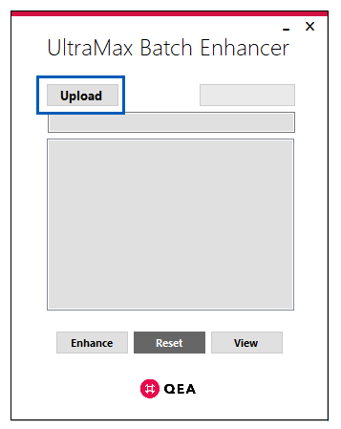

1. Select a folder containing the Thermal Image file(s) that need to have UltraMax performed; Click on “OK”

**Note:** The application will only upload files that are of .jpg file format, Thermal Image file type, and ready for UltraMax enhancement

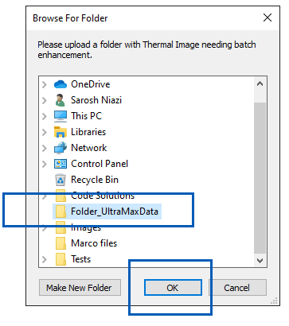

1. Confirm the folder path loads; Confirm the Thermal Image file(s) load

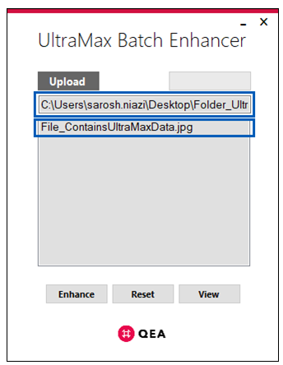

# Enhance Image(s)

1. Once the Thermal Image file(s) are uploaded, click on a file; Click on “Enhance”

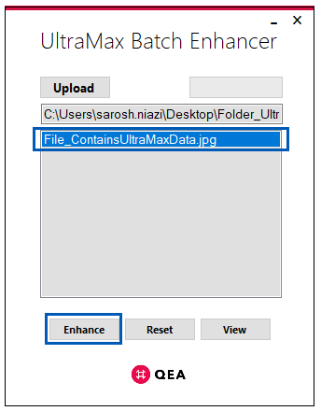

1. A message is returned, confirming that UltraMax was performed on all image(s) loaded

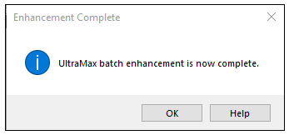

1. Open a Thermal Image file; Confirm that UltraMax has been performed on the image

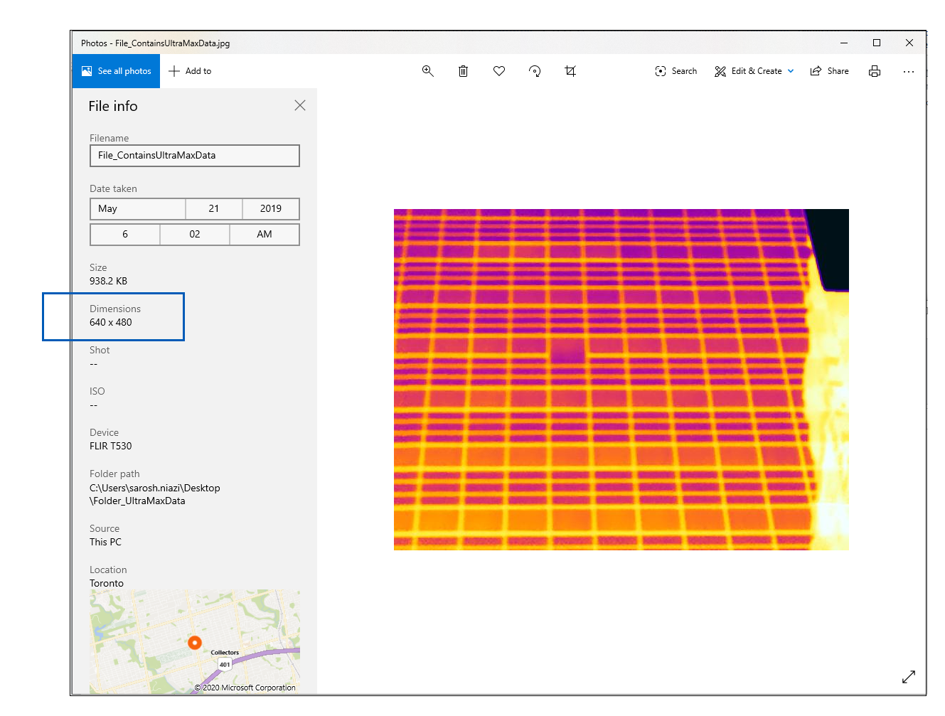

1. Confirm that a back-up folder has been created with the original Thermal Image

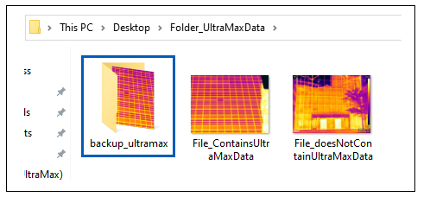

# Reset Image(s)

1. Click on “Reset”

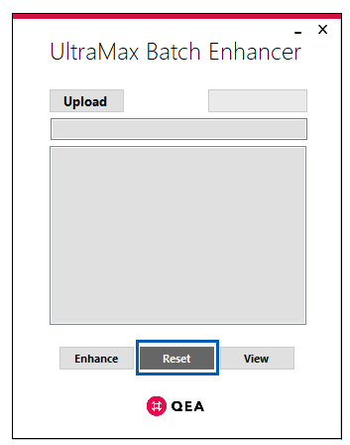

1. Confirm the folder path is unloaded; Confirm the Thermal Image files are unloaded

# View Image(s) Folder

1. Click on “View”

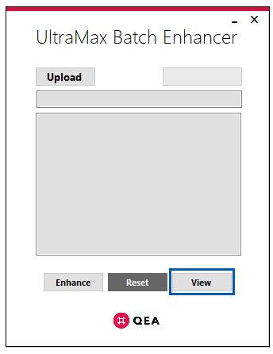

1. The folder with the list of loaded Thermal Image files is opened